Review: Chapter 2

**Written Section:**

**2.1:** The difference between references and primitive types is that primitive types are data types which hold their information or values that are in it. While references just point to the where the values are and do not hold the information.

**2.3:** the difference between array and array list is that array are set and you cannot change the length of them once created but with arraylist you can changed the length of them. Also, with arraylist you can just do objects not primitive types.

**2.4:** the way exceptions work in Java is that while the program is happening there is a problem that affects the run time and an exception will happen to let the program finish still and take care of whatever problem happened.

**In theory:**

**2.7:** outcomes would be “44” for the first line meaning

 and for the second line it would be “5 7”

**2.8:** foo would return 0 because it hits the try block which return 0 and it exists foo before it can reach the finally block. In the bar method ArithmeticException is thrown because it the NullPointerException first but then hit the finally block and return the stuff inside it.

**Programming:**

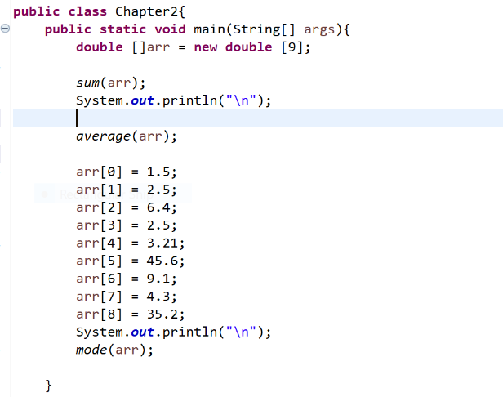**2.14:**

What I had In the main to make the double array and filled it with Randoms number in the sum and average methods, before the mode one I filled the elements myself so there could actually be an answer always.

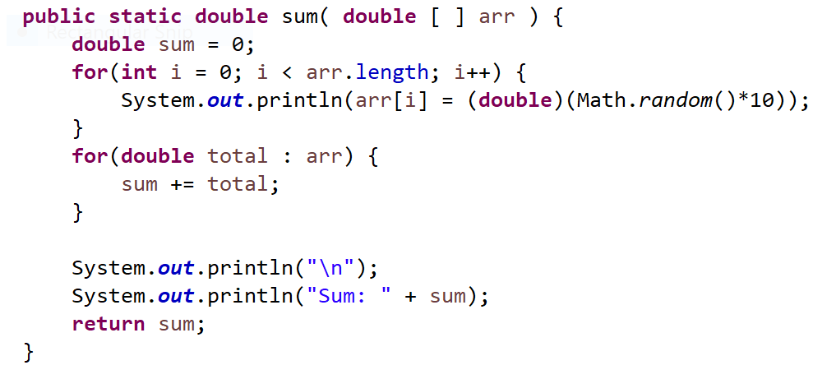the sum one filled array random and for loop enhanced for loop with temp variable total and added it to sum to add all the elements and return it.

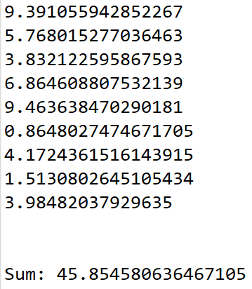Here is the answers made sure it was right by adding it to a calculator.

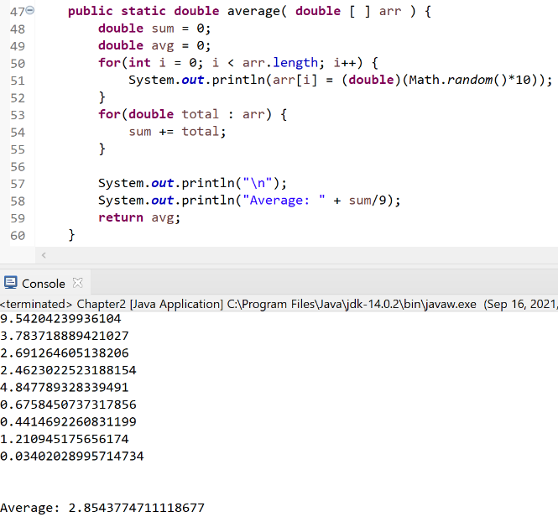

Used the sum stuff to get the sum of array then I knew the length was 9 so I just divided by 9. I checked my results with a calculator and it was correct.

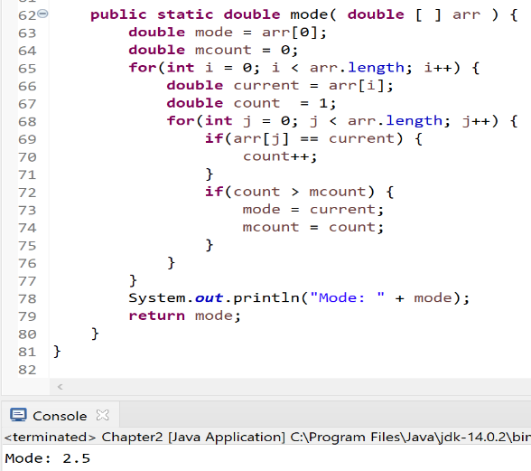here is the mode code where I already had array filled so I made a variable that starts at the first element and had a mcounter the would be compared to another counter. I had a for loop go through the array then I had another for loop go through the same array inside the other for loop to compare each element and I had an if statement that if the elements were the same it would add to count. And then a last for loop then would check if count was greater than count which is how it starts so I had it reset to equal the same so after it went through the for loop again if it added to count then that was the mode. I made 2.5 repeat twice and it returned it so it was correct.

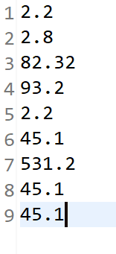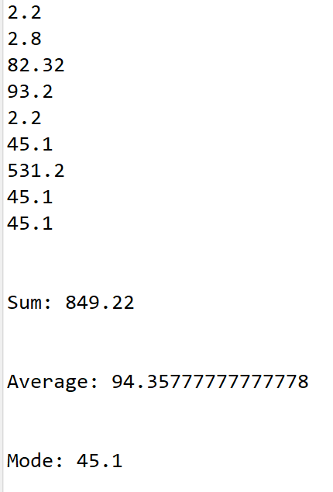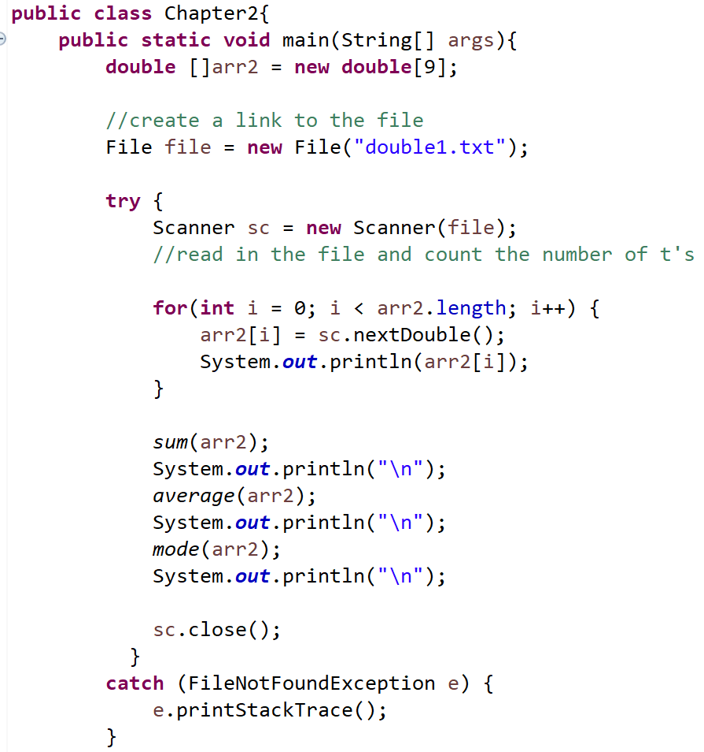**2.28:** wrote the txt file and read it into the main as a double array to fill it in then I used my methods from before to get sum, average, and mode. I had to change my methods a little because I could make the other arrays from beofre in them so I just made it in the main to do random array of 9 elements.